Carrollwood K-8 Family STEAM Night
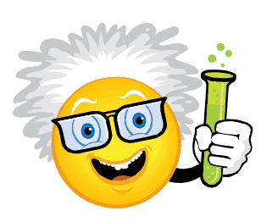
Mad Science Labs & Book Fair Event

Thursday, 10/12 5:00 – 7:00 PM
5:00 – Arrival and Dinner (Provided by our awesome PTSA)
5:30 – Whole Group Presentation (Community Outreach)
6:00 – 7:30 – Mad Lab Rotations & Book Fair Event
(Presented by Carrollwood’s Finest Mad Scientists, Staff, and Media Specialist!)
(Event RSVP and Lab Sign-up will be sent home next week!)

